**Class works:**

Task 1: To perform discrete time exponential harmonics using MATLAB.

Code:

clc;

clear all;

close all;

N=3;

w=2*pi/N;

fs=500; %real time sample rate(Hz)

t=-3:1/fs:3; %time index(s)

n=-3:1:3; %sample index

for cnt=1:4,

subplot(4,2,cnt*2-1);

h=plot(t,real(exp(j*cnt*w*t)),'r');

set(h,'Linewidth',0.1);

hold on;

h=stem(n,real(exp(j*cnt*w*n)),'.');

hold off;

box off;

grid on;

xlim([min(t) max(t)]);

ylim([-1.1 1.1]);

ylabel(sprintf('\\phi_%d',cnt));

subplot(4,2,cnt*2);

h=plot(t,imag(exp(j*cnt*w*t)),'r');

set(h,'Linewidth',0.1);

hold on;

h=stem(n,imag(exp(j*cnt*w*n)),'.');

hold off;

box off;

grid on;

xlim([min(t) max(t)]);

ylim([-1.1 1.1]);

ylabel(sprintf('\\phi_%d',cnt));

end

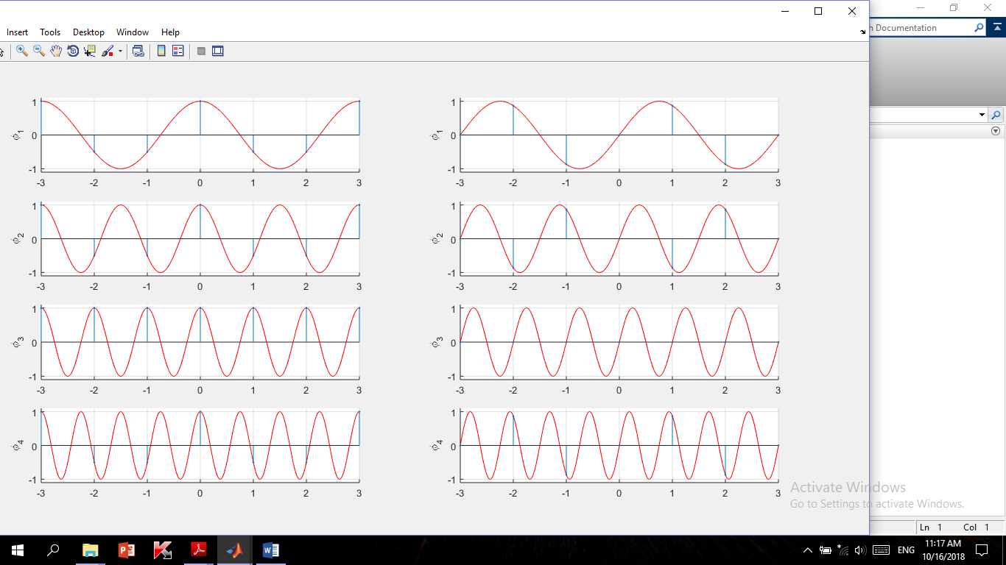

Figure 3.1 : Discrete time exponential harmonics

Task 2: To perform cross correlation for the given sequences .

Code :

clc;

clear all;

close all;

x=input('Enter the sequence 1:');

h=input('Enter the sequence 2:');

y=xcorr(x,h); 3

figure;

subplot(2,2,1)

stem(x);

xlabel('n-->');

ylabel('Amp-->');

title('input sequence 1');

subplot(2,2,2)

stem(h);

xlabel('n-->');

ylabel('Amp-->');

title('input sequence 2');

subplot(2,2,3)

stem(y)

xlabel('n-->');

ylabel('Amp-->');

title('output sequence ');

subplot(2,2,4)

stem(fliplr(y));

xlabel('n-->');

ylabel('Amp-->');

title('flipped output sequence');

disp('the resultant is ');

fliplr(y);

Output:

Enter the sequence 1:[1 2 1 1 3]

Enter the sequence 2:[3 4 3 2 1]

ans = 3

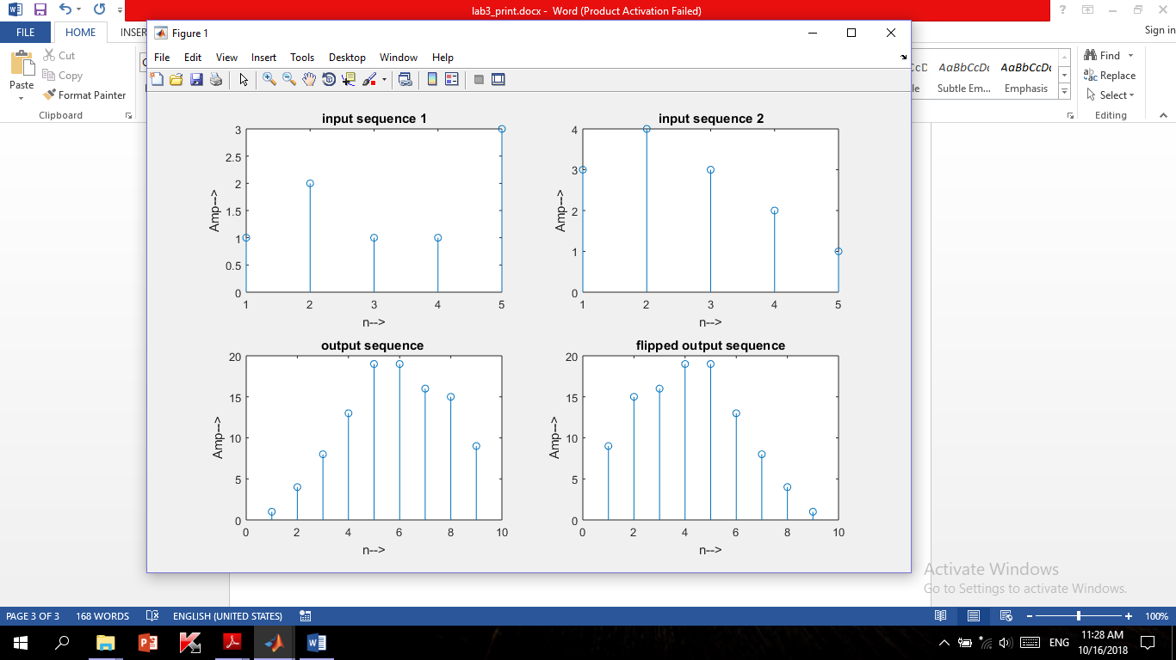the resultant is

Figure 3.2 : Cross correlation for the given sequences

Home work:

Problem: x1(n)= sin(pi*n/2) , x2(n)= cos(pi*n/3) ,

Find cross correlation between x1(n) & x2(n).

Code :

clc;

clear all;

close all;

fs=50;

n=-3:1/fs:3;

x1=sin(n*pi/2);

x2=cos(n*pi/3);

y=xcorr(x1,x2);

figure;

subplot(2,2,1)

stem(x1);

xlabel('n-->');

ylabel('Amp-->');

title('input sequence 1');

subplot(2,2,2)

stem(x2);

xlabel('n-->');

ylabel('Amp-->');

title('input sequence 2');

subplot(2,2,3)

stem(y);

xlabel('n-->');

ylabel('Amp-->');

title('output sequence ');

subplot(2,2,4)

stem(fliplr(y));

xlabel('n-->');

ylabel('Amp-->');

title('flipped output sequence');

disp('the resultant is ');

fliplr(y);

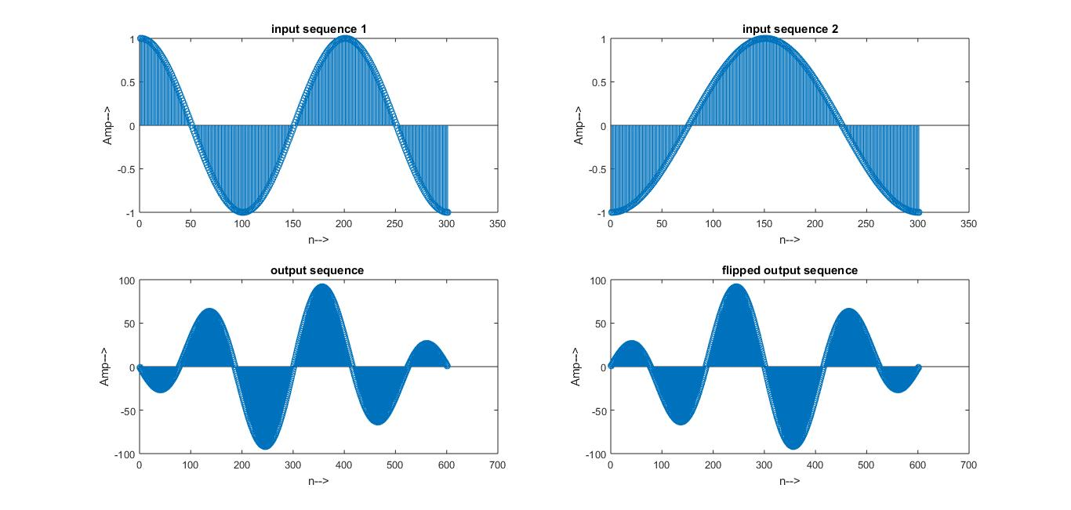

Figure 3.6 : Cross correlation for the given sequences

Problem:

Find DFT,IDFT,FFT,IFFT of x2(n)= cos(pi*n/3).

Code:

clc;

clear all;

close all;

fs=50;

n=1:1/fs:10;

xn=cos(n*pi/3);

N=length(xn);

Xk=zeros(1,N);

iXk=zeros(1,N);

for k=0:N-1

for n=0:N-1

Xk(k+1)=Xk(k+1)+(xn(n+1)*exp((-i)*2*pi*k*n/N));

end

end

t=0:N-1;

subplot('421');

stem(t,xn);

ylabel('Amplitude');

xlabel('Time Index');

title('Input sequence');

disp('The discrete fourier transform of x(n)');

disp(Xk);

t=0:N-1;

subplot('422');

stem(t,Xk);

ylabel('Amplitude');

xlabel('Time Index');

title('X(k)');

magnitude=abs(Xk);

disp('the magnitude response of X(k)');

disp(magnitude);

t=0:N-1;

subplot('423');

stem(t,magnitude);

ylabel('Amplitude');

xlabel('k');

title('magnitude response');

%to find the phase of individual DFT points

phase=angle(Xk);

%code block to plot the phase response

disp('the phase response of X(k)');

disp(phase);

t=0:N-1;

subplot('424');

stem(t,phase);

ylabel('phase');

xlabel('K');

title('phase response');

%IDFT

%%code block to find IDFT of the sequence

for n=0:N-1

for k=0:N-1

iXk(n+1)=iXk(n+1)+(Xk(k+1)*exp((i)*2*pi*k*n/N));

end

end

iXk=iXk./N;

t=0:N-1;

subplot('425');

stem(t,xn);

ylabel('amplitude');

xlabel('Time index');

title('IDFT sequence');

%code block to plot the FFT of i/p sequence using inbuilt function

x2=fft(xn);

subplot('426');

stem(t,x2);

ylabel('amplitude');

xlabel('Time index');

title('FFT of input sequence');

x3=ifft(x2);

subplot('427');

stem(t,x3);

ylabel('amplitude');

xlabel('Time index');

title('IFFT sequence');

Figure 3.7: Performing DFT,IDFT,FFT,IFFT

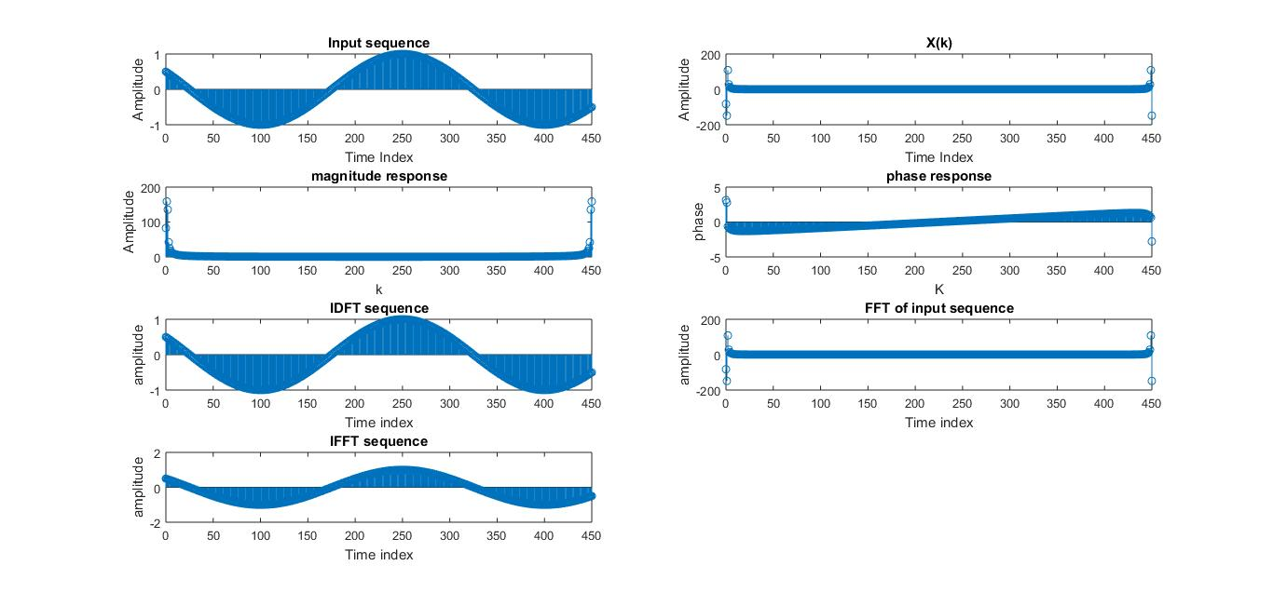

Problem :

x(n)= exp(j*n*k/3) + exp(j*2*n*k/5), show 5 harmonics of 20th component.

Code :

clc;

clear all;

close all;

N=3;

w=2*pi*20/N;

fs=200; %real time sample rate(Hz)

n=-3:1/fs:3; %sample index

for cnt=1:5

y=exp(j*w*n*cnt/3)+exp(j*w*2*n*cnt/5);

subplot(5,2,(cnt)*2-1);

h=stem(n,real(y),'.');

hold off;

box off;

grid on;

xlim([min(n) max(n)]);

ylim([-2.5 2.5]);

ylabel(sprintf('\\phi_%d',cnt));

subplot(5,2,(cnt)*2);

h=stem(n,imag(y),'.');

hold off;

box off;

grid on;

xlim([min(n) max(n)]);

ylim([-2.5 2.5]);

ylabel(sprintf('\\phi_%d',cnt));

end

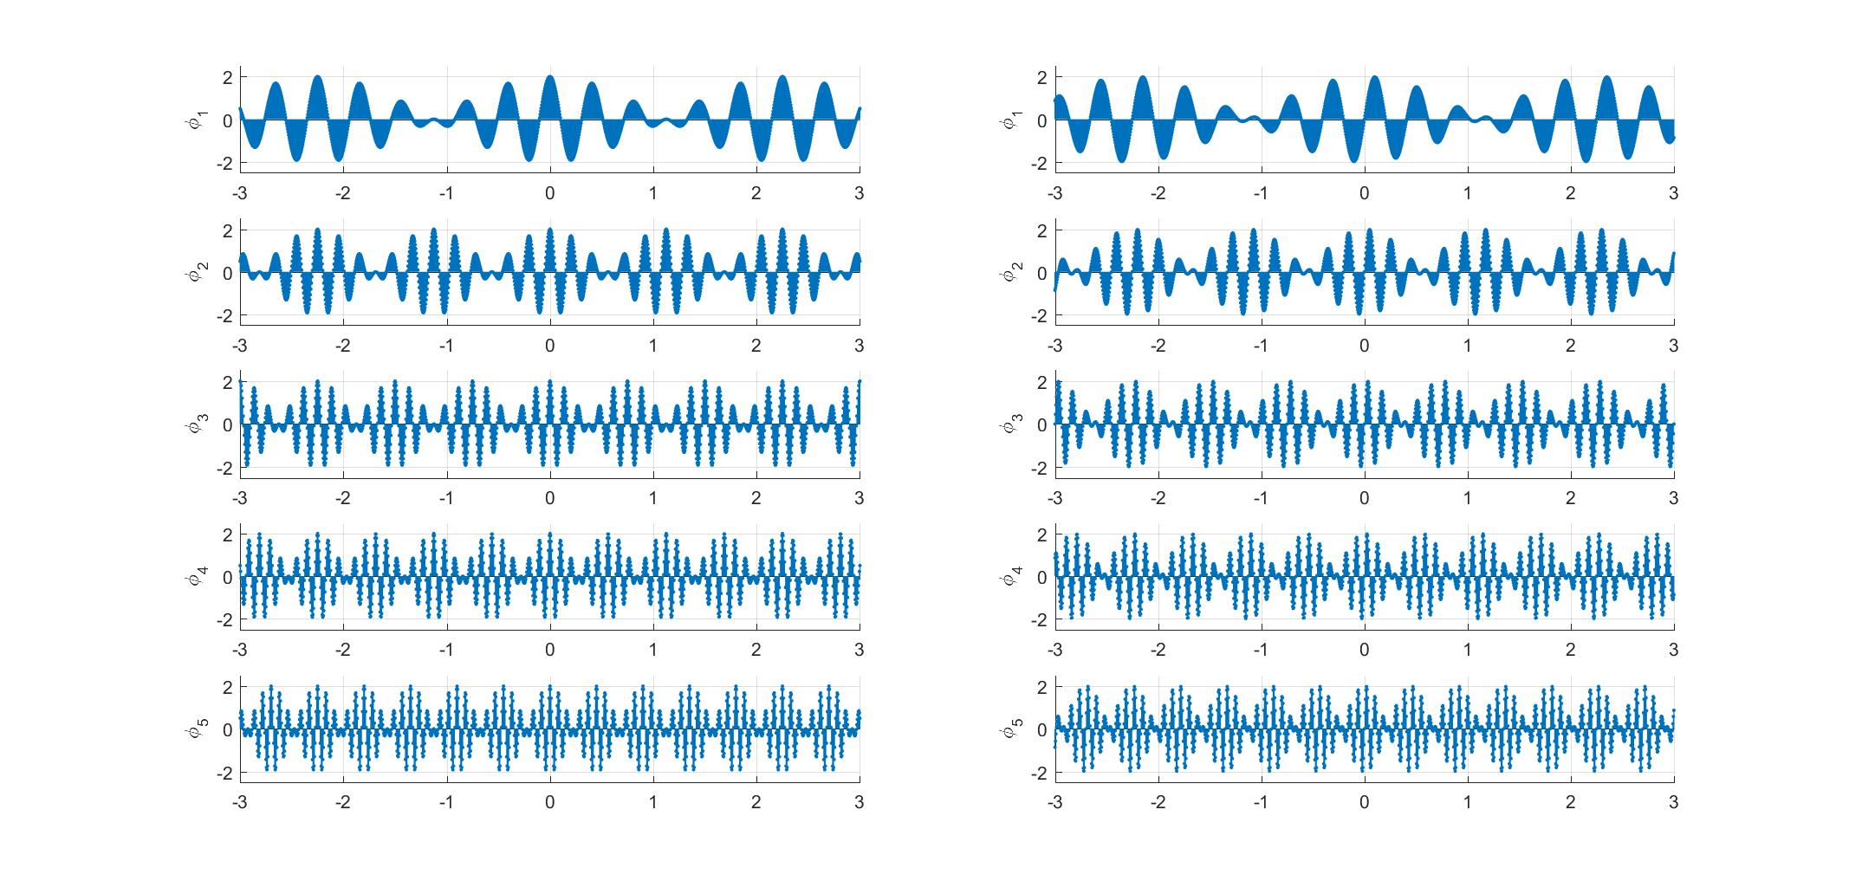

Figure 3.8: 5 harmonics of the 20th component of given signal.

Task : To perform discrete fourier transform

Code :

clc;

clear all;

close all;

disp('The sequence from the user');

xn=input('Enter the input sequence : ');

N=length(xn);

Xk=zeros(1,N);

iXk=zeros(1,N);

for k=0:N-1

for n=0:N-1

Xk(k+1)=Xk(k+1)+(xn(n+1)*exp((-i)*2*pi*k*n/N));

end

end

t=0:N-1;

subplot('421');

stem(t,xn);

ylabel('Amplitude');

xlabel('Time Index');

title('Input sequence');

disp('The discrete fourier transform of x(n)');

disp(Xk);

t=0:N-1;

subplot('422');

stem(t,Xk);

ylabel('Amplitude');

xlabel('Time Index');

title('X(k)');

magnitude=abs(Xk);

disp('the magnitude response of X(k)');

disp(magnitude);

t=0:N-1;

subplot('423');

stem(t,magnitude);

ylabel('Amplitude');xlabel('k');

title('magnitude response');

%to find the phase of individual DFT points

phase=angle(Xk);

%code block to plot the phase response

disp('the phase response of X(k)');

disp(phase);

t=0:N-1;

subplot('424');

stem(t,phase);

ylabel('phase');

xlabel('K');

title('phase response');

%IDFT

%%code block to find IDFT of the sequence

for n=0:N-1

for k=0:N-1

iXk(n+1)=iXk(n+1)+(Xk(k+1)*exp((i)*2*pi*k*n/N));

end

end

iXk=iXk./N;

t=0:N-1;

subplot('425');

stem(t,xn);

ylabel('amplitude');

xlabel('Time index');

title('IDFT sequence');

%code block to plot the FFT of i/p sequence using inbuilt function

x2=fft(xn);

subplot('426');

stem(t,x2);

ylabel('amplitude');

xlabel('Time index');

title('FFT of input sequence');

x3=ifft(x2);

subplot('427');

stem(t,x3);

ylabel('amplitude');

xlabel('Time index');

title('IFFT sequence');

Output:

The sequence from the user

Enter the input sequence : [2 3 5 7 8]

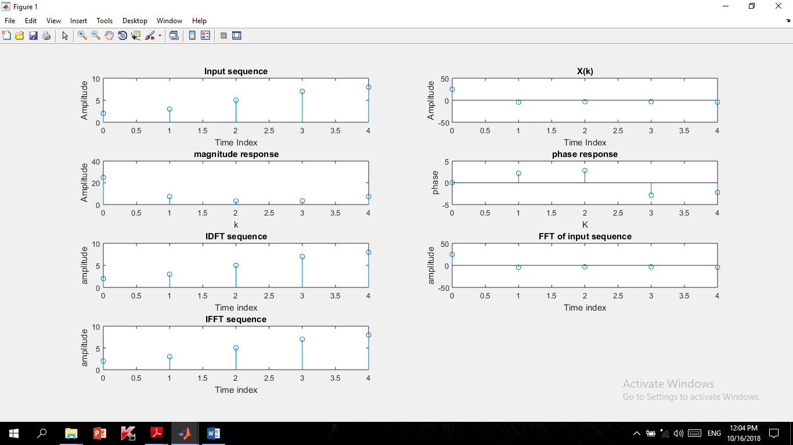

Figure 3.5: Performing DFT,IDFT,FFT,IFFT

Task 3 :Correlation / Cross correlation for the given sequences.

Code :

clc;

close all;

clear all;

x=rand(100,1);

y=x+rand(100,1);

subplot(2,2,1);

plot(x,y,'o','MarkerSize',10) %2-D scatter plot

r=corrcoef(x,y);

z=randn(100,1);

subplot(2,2,2);

plot3(x,y,z,'.');

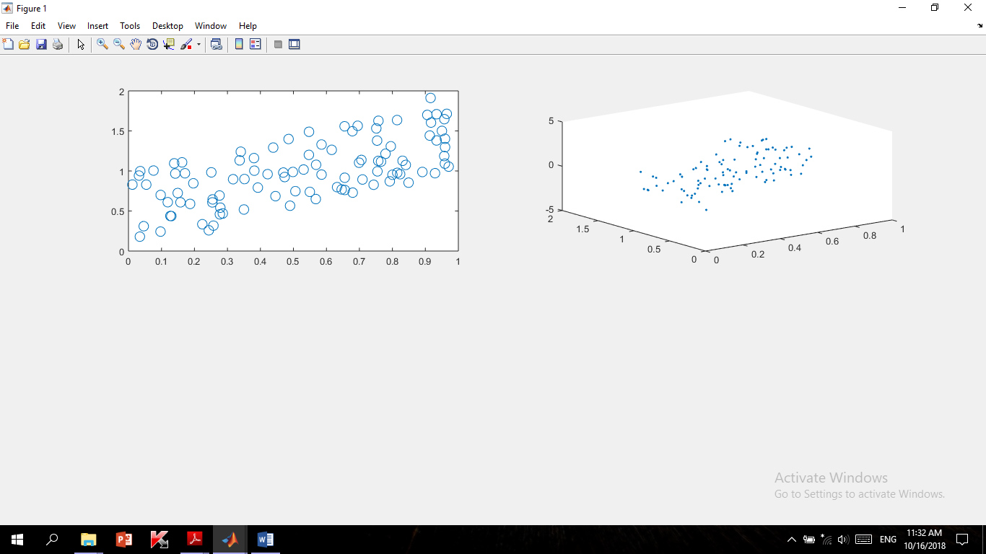



Figure 3.4 : Cross correlation for the given sequences (3D plot)

Figure 3.3 : Cross correlation for the given sequences (2D scatter plot)